Introduction (NACA 23015 Airfoil)
Airfoils are aeronautical designs, which create lift with minimum drag. The aerodynamic and geometry of the airfoil chosen is the key factor in the performance of any aircraft wing. The 5-digit series of NACA (National Advisory Committee of Aeronautics) was created to give better lift capabilities and desirable stalling behavior to the aviation use.

A 5-digit airfoil with moderate thickness (15% of chord) and a cambered design is the NACA 23015, which has higher lift at small angles of attack. Its aero-geometric requirements are that the highest camber is at 15 percent chord (partial) that gives it good lift performance and a better stability. These properties have made the NACA 23015 airfoil to be used extensively in general aviation, rotorcraft blades, and wind turbine blades.
This study/assignment has examined and presented the geometric characteristics, camber and thickness distribution, aerodynamic characteristics and important aerodynamic locations (leading edge, trailing edge, maximum camber point, and maximum thickness point) of the NACA 23015 airfoil. The results of these analyses can be used to understand the effect of the airfoil shape on the lift production, the drag properties, and the aerodynamic efficiency of the results.

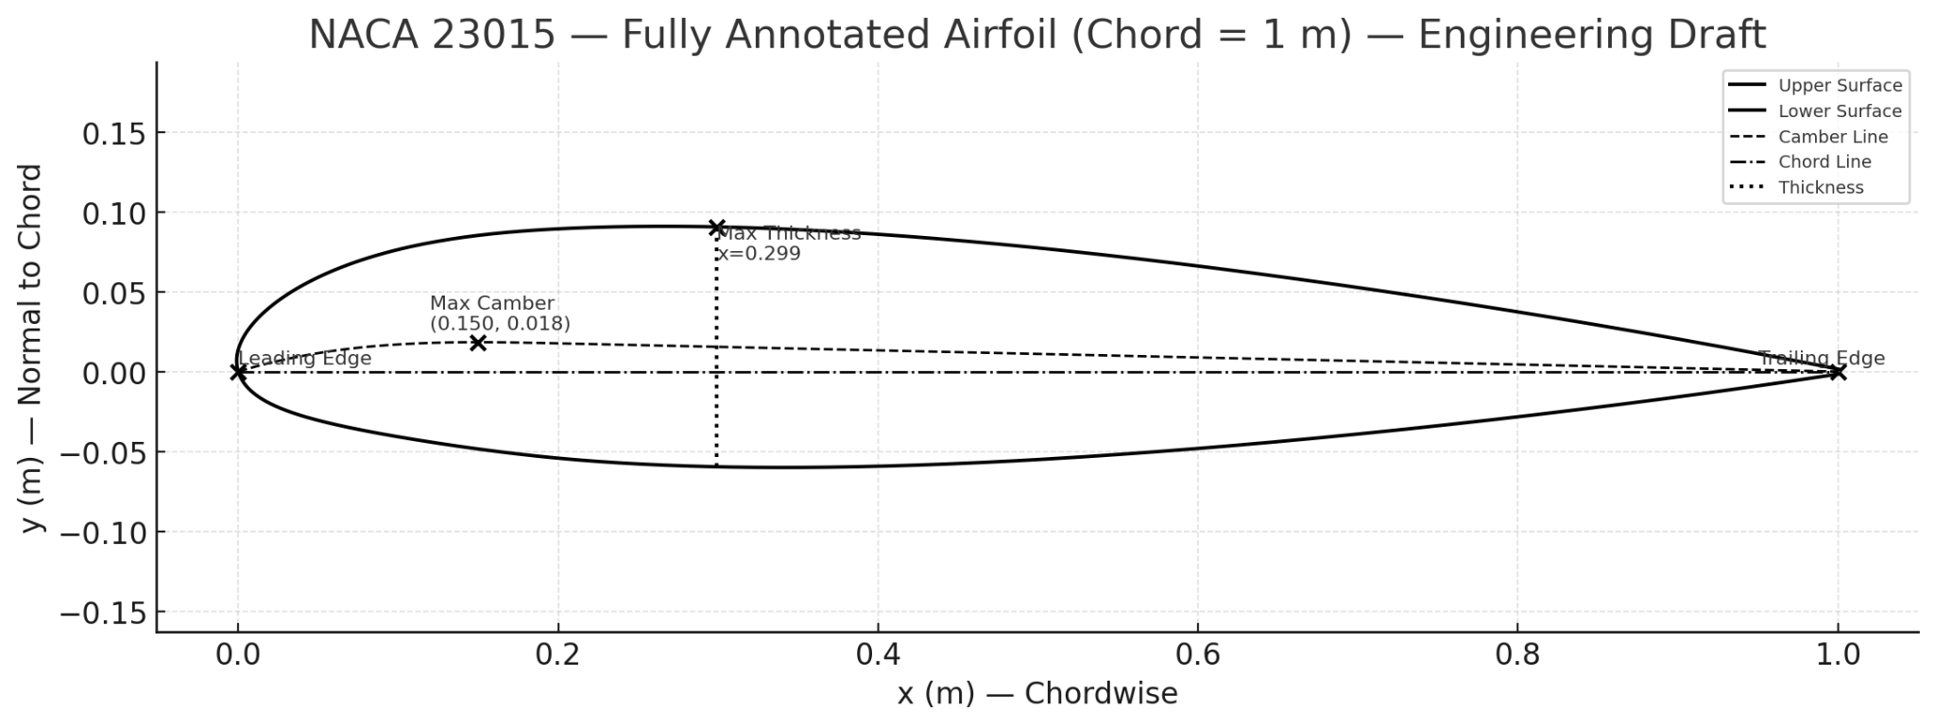

2. NACA 23015 — what 23015 means (5-digit series):

For a 5-digit NACA code :

1.L (1st digit) — relates to the design lift (the theoretical “design”/ideal lift coefficient). The design lift coefficient (ideal) is CL,I​=0.15×L.
For 23015, L = 2 ,CL=0.30

2.P (2nd digit) — chordwise location of maximum camber, given by xmax_camber=0.05×P(P x 5 percent of the chord).

3. S (3rd digit) — camber type: 0 = simple camber, 1 = reflex camber.
For 23015, S=0S=0S=0 → simple camber (non-reflex).
4. (4th–5th digits) — maximum thickness as percent of chord
For 23015, 15 → 15% thickness (0.15 m for chord = 1 m).

Lift-Curve Analysis:

